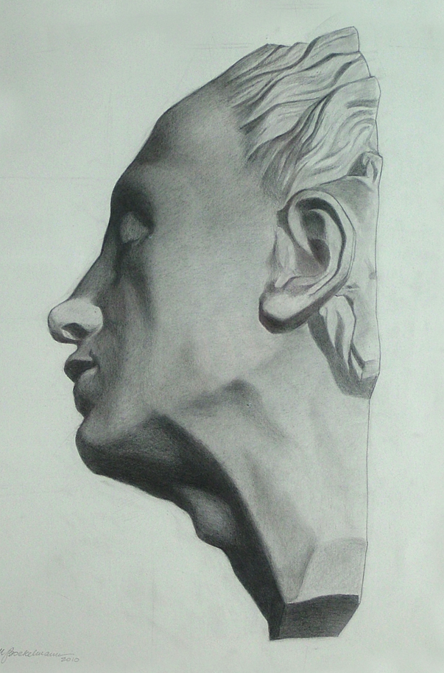
Gold Light Studios

Classical Art Studios and Atelier
Application for classes:

Your name:
______________________________________________________________________
Address:
______________________________________________________________________

______________________________________________________________________

Email:
______________________________________________________________________

Phone:
______________________________________________________________________

Class name:

Date and time:

How did you hear about us?

I’m paying by check

I’m paying by paypal

If paying by paypal or check please send application to:
If paying by check please make payable to “John Murdoch” and send to:

Gold Light Studios
512 Scott Road
Perkasie, PA
18944

